**ASSIGNMENT 1**

NAME : JUDAH PAULO LL. VIÑAS DATE : SEPTEMBER 3, 2022

PROGRAM&SECTION : BSIT-1F

CCIT 102 | COMPUTER PROGRAMMING

1. What is flowchart?

* **Flowchart** is a graphical representation of an algorithm. Programmers often use it as a program-planning tool to solve a problem. It makes use of symbols which are connected among them to indicate the flow of information and processing.

1. What are the different symbols used in flowchart? Give brief description of each function.

* **Basic Symbols used in Flowchart Design**

1. 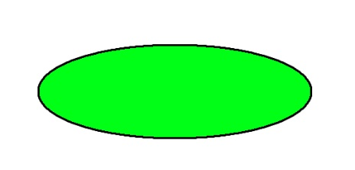**Terminal** - the oval symbol indicates Start, Stop and Halt in a program’s logic flow. A pause/halt is generally used in a program logic under some error conditions. Terminal is the first and last symbols in the flowchart.
2. 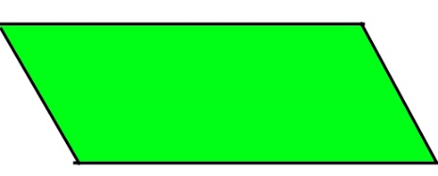**Input/Output -** a parallelogram denotes any function of input/output type. Program instructions that take input from input devices and display output on output devices are indicated with parallelogram in a flowchart.
3. **Processing** - a rectangle represents arithmetic instructions. All arithmetic processes such as adding, subtracting, multiplication and division are indicated by action or process symbol.
4. 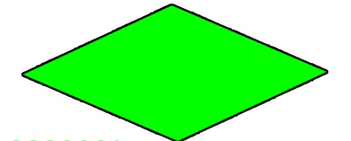**Decision** – diamond/rhombus symbol represents a decision point. Decision based operations such as yes/no question or true/false are indicated by diamond in flowchart.
5. 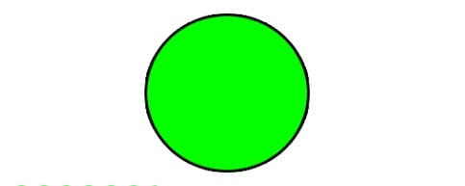**Connectors** - It is represented by a circle. whenever flowchart becomes complex or it spreads over more than one page, it is useful to use connectors to avoid any confusions.
6. **Flow Lines** - flow lines indicate the exact sequence in which instructions are executed. Arrows represent the direction of flow of control and relationship among different symbols of flowchart.
7. Write an algorithm, pseudocode and draw a flowchart that will show the process of the following:
   1. Compute the average of 3 quizzes.

**PSEUDOCODE**

BEGIN

DECLARE quiz1, quiz2, quiz3, sum As Integer

DECLARE average As Real

PRINT (“Enter your 3 score”)

INPUT quiz1, quiz2 and quiz3

COMPUTE sum = quiz1 + quiz2 + quiz3

COMPUTE average = sum/3

PRINT (“The sum is”)

PRINT (sum)

PRINT (“The average is”)

PRINT (average)

END

**ALGORITHM**

Step 1: Start

Step 2: Declare a variables quiz1, quiz2, quiz3, sum and average.

Step 3: Read quiz1, quiz2 and quiz3.

Step 4: Add quiz1, quiz2 and quiz3, and assign the result to variable sum.

Step 5: Divide the result in variable sum by 3, and assign the result to variable average.

Step 6: Print the value in variable average.

Step 7: Stop

Display average

Display sum

Compute

average = sum/3

Compute

sum = quiz1 +quiz2 +quiz3

**FLOWCHART**

Input

quiz1, quiz2, quiz3

* 1. Convert Celsius to Fahrenheit.

**PSEUDOCODE**

BEGIN

DECLARE Celsius, Fahrenheit As Real

PRINT (“Celsius to Fahrenheit”)

INPUT Celsius

COMPUTE Fahrenheit = ((Celsius/5)*9)+32

PRINT (“The Fahrenheit is”)

PRINT (Fahrenheit)

END

**ALGORITHM**

Step 1: Start

Step 2: Declare a variable Celsius and Fahrenheit.

Step 3: Get Celsius..

Step 4: Divide Celsius by 5, then multiply by 9 and add 32, and assign the result to variable Fahrenheit.

Step 5: Print the value in variable Fahrenheit.

Step 6: Stop

**FLOWCHART**

Input

Celsius

Compute

Fahrenheit = ((Celsius/5)*9)+32

Display Fahrenheit

* 1. Find the largest among three different numbers entered by the user.

**ALGORITHM**

Step 1: Start

Step 2: Declare a variable num1, num2 and num3.

Step 3: If num1>num2 and num1>num3 then print num1 is the GREATEST.

Step 4: Otherwise, if num2>num1 and num2>num3 then print num2 is the GREATEST.

Step 5: Otherwise, print num3 is the GREATEST.

Step 6: Stop

**PSEUDOCODE**

BEGIN

DECLARE num1, num2, num3 As Integer

PRINT (“What is the greatest number”)

INPUT num1, num2, num3

IF num1>num2 AND num1>num3 THEN

………Print “num1 is the GREATEST”

ELSE IF num2>num1 AND num2>num3 THEN

………Print “num2 is the GREATEST”

ELSE

………Print “num3 is the GREATEST”

ENDIF

END

**FLOWCHART**

Input

num1, num2, num3

Print

“num1 is the GREATEST”

Print

“num3 is the GREATEST”

Print

“num2 is the GREATEST”

YES

YES

NO

NO

NO

YES

If

num1>num3

If

num2>num3

If

num1>num2